Friday Afternoon – WEEK ONE
Hello Year Two! Here are your activities for Friday Afternoon – please take a photo and post it on your Dojo Page.
Activity One –
CREST Awards – Be Seen, Be Safe

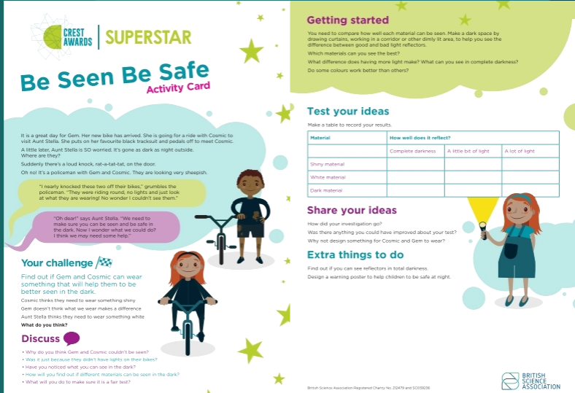

Material | How well does it reflect?
 | Complete darkness | A little bit of light | A lot of light.
Dark Material
White Material
Shiny Material

Activity Two – My family tree.
Create a poster that shows who is in your family.
