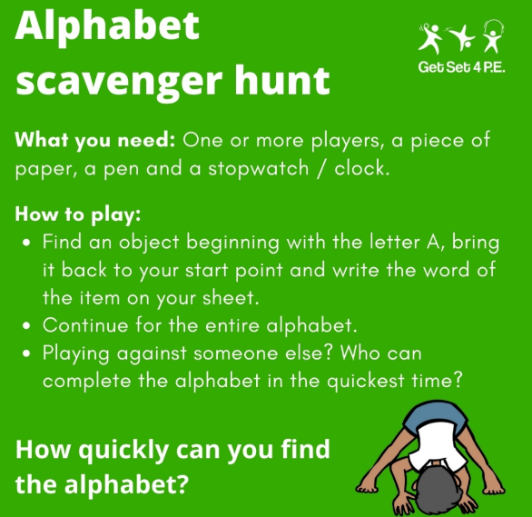
A__________________________
B__________________________
C__________________________
D__________________________
E__________________________
F__________________________
G__________________________
H__________________________
I__________________________
J__________________________
K__________________________
L__________________________
M__________________________
N__________________________
O__________________________
P__________________________
Q__________________________
R__________________________
S__________________________
Don’t forget to take pictures and post on to you Class Dojo profile.
T__________________________
U__________________________
V__________________________
W_________________________
X__________________________
Y__________________________
Z__________________________

